Software Analysis Report

for

Stocks Trend Prediction

Version 1.0

Prepared by

|  |  |  |
| --- | --- | --- |
| Hassan Ahmed Khan | 201907008 | hassanahmedkhan2018@gmail.com |

|  |  |
| --- | --- |
| Internal :  External: | Engr. Kashif Jamil  - |
| Discipline: | BS – Software Engineering |
|  |  |
|  |  |
|  | |

Table of Contents

1. **Problem Statement……………………………………………………………………...73**
2. **Problem Modelling……………………………………………………………………...73**
3. **System Architecture…………………………………………………………………….73**
4. **LSTM Architecture.........................................................................................................74**
5. **Non – Functional Requirements……………………………………………………….74**
   1. Reliability…………………………………………………………………….74
   2. Security………………………………………………………………………74
   3. Maintainability……………………………………………………………….75
   4. Portability…………………………………………………………………….75
6. **Use – Case Diagram…………………………………………………………………….75**
   1. **Problem Statement:**

The stock has been an unpredictable curve in the picture. Its essence had been living and delighting for a long time. The same may be said for the company. Rather than investing and obtaining a bank loan approval, the organisation built it as a superior source of revenue generating. From a business standpoint, it is far more efficient and less stressful.

* 1. **Problem Modelling**

The analysis phase is to study, analyse and gather the requirements of the project. The requirements related to the algorithm of predicting future stock prices, are gathered through researching papers and also some advice from the supervisor. The requirements of the time series algorithms and evaluation methods of the algorithms will be analysed.

**1.3 System Architecture:**

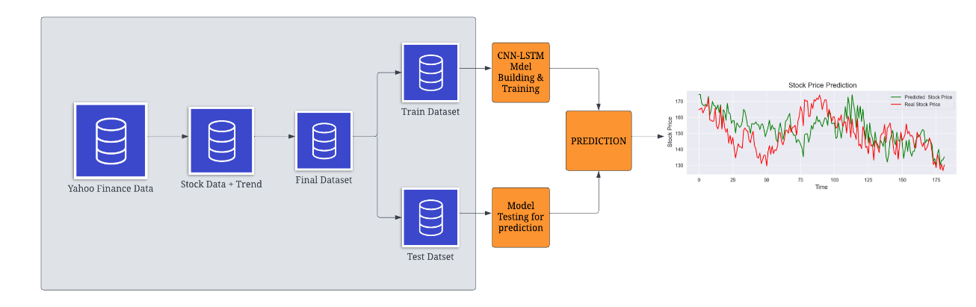

|  |  |
| --- | --- |
| https://documents.lucid.app/documents/83fd8058-3b6f-4b85-b73e-552704e34ede/pages/0_0?a=1399&x=112&y=629&w=1496&h=682&store=1&accept=image%2F*&auth=LCA%2068a64592ca16b8b9aa08e345aaecfd88d3f3d88c-ts%3D1674048154 | https://documents.lucid.app/documents/83fd8058-3b6f-4b85-b73e-552704e34ede/pages/0_0?a=1399&x=158&y=1263&w=1364&h=814&store=1&accept=image%2F*&auth=LCA%2018da220d20d34cd2c6eeadb64b5c4228bcb1a51b-ts%3D1674048154 |

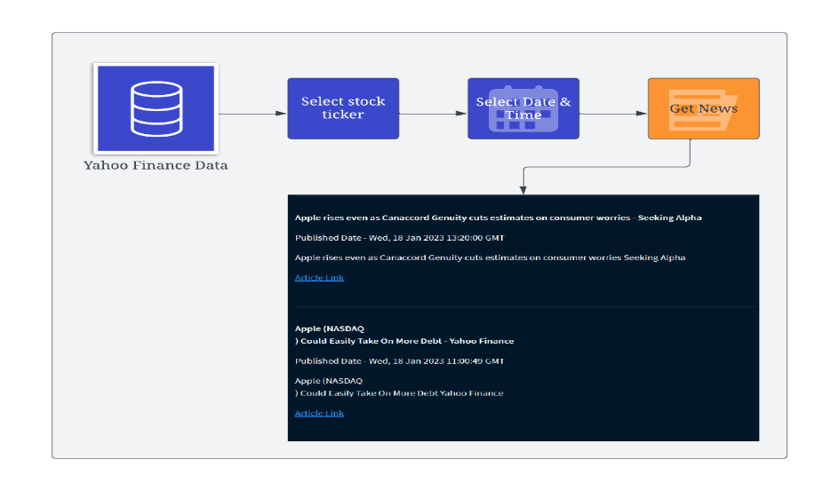

* 1. **LSTM Architecture:**

To overcome from this problem, I come up with another version of RNN that is Long Short-Term Memory (LSTM). This is a special kind of RNN that is capable of learning long-term dependencies. This is specially designed to avoid long-term dependency problems and memorize information for long period of time. LSTM can process entire sequence of datasets and uses a supervised learning process.

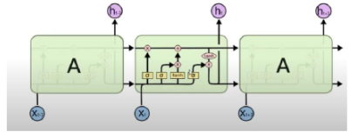

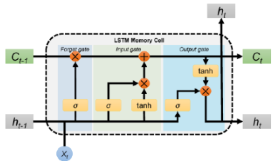

LSTM Memory Cell

* 1. **Non-Functional Requirements**

1. Reliability:

The reliability of the product will be dependent on the accuracy of the dataset of purchase, how much stock was purchased, high and low value range as wellas opening and closing figures. Also the stock data used in the training would determine the reliability of the software.

2. Security:

The user will only be able to access the website using his login details and will not be able to access the computations happening at the back end.

3. Maintainability:

The maintenance of the product would require training of the software by recent data so that there commendations are up to date. The database has to be updated with recent values.

4. Portability:

The website is completely portable and the recommendations completely trustworthy as the data is dynamically updated.

* 1. **Use Case Diagram**



